**MINOR-1 PROJECT**

**SYNOPSIS/MID/END Report**

**Virtual Painter and Character Recognition Using OpenCV**

Submitted By:

|  |  |  |
| --- | --- | --- |
| **Name** | **Roll No** | **Branch** |
| Akansh Mowar | R110219005 | CCVT |
| Aviral Jindal | R110219030 | CCVT |
| Kriti Niranjan | R110219071 | CCVT |
| Bhavya Jain | R110219036 | CCVT |

**Under the guidance of**

**Dr. Lalit Kane**

**Associate Professor**



School of Computer Science

**UNIVERSITY OF PETROLEUM AND ENERGY STUDIES**

**B. Tech CCVT, 5th SEM, Batch: 2019-23**

**Synopsis Report (2021-22)**

# Project Title

# Virtual Painter and Character Recognition Using OpenCV

# Abstract

Virtual Sketch is in where we can draw by just capturing the motion of a tip of finger with a camera. One object i.e the tip of the finger is mainly used as the marker. The color tracking and detection processes are used to achieve the goal of this project. Analyze the data and give the output.

# Introduction

Nowadays, the interaction between people and the machines is mainly completed through the mouse, keyboard, remote control, touch screen, and other direct contact manner . The communication by natural and intuitive non-contact manner is usually considered to be flexible and efficient; many researchers have thus tried efforts to make the machine identify other intentions and information through the non-contact manner like people . gesture recognition can be simply categorized into two methods based on devices which are used to capture gestures: wearable sensor-based methods and optical camera-based methods. In optical camera based method, optical cameras are used which record a set of images to capture gesture movements from a distance.

Open CV : OpenCV (Open-Source Computer Vision Library) is an open source computer vision and machine learning software library. OpenCV was built to provide a common infrastructure for computer vision applications and to accelerate the use of machine perception in the commercial products. Being a BSD-licensed product, OpenCV makes it easy for businesses to utilize and modify the code.

Contour detection:  A Contour Line indicates a curved line representing the boundary of the same values or the same intensities. A contour map is the most straightforward example we can think of.  the concept of edges lies in a local range while the concept of contours is at the overall boundary of a figure. Edges are points whose values change significantly compared to their neighboring points. Contours, on the other hand, are closed curves which are obtained from edges and depicting a boundary of figures.

Background Subtraction: Background subtraction is a major preprocessing step In many vision-based applications. For example, consider the case of a visitor counter where a static camera takes the number of visitors entering or leaving the room, or a traffic camera extracting information about the vehicles etc. In all these cases, first you need to extract the person or vehicles alone. Technically, you need to extract the moving foreground from static background.

Skin Detection Method: Process of finding skin-colored pixels and regions in an image or a video . Often used as a cue for detecting, localizing and observing targets containing skin (like faces and hands in an image) . Plays an important role in human motion analysis and face detection.

.

.

ImageImage

# Literature Review

Automatic object tracking has many uses in computing, such as Computer vision and human-machine interaction . Various applications of tracking algorithms are suggested in the literature. One group of researchers used it to translate sign languages , others for hand gesture recognition , another group for text tracking and recognition , and to monitor the body movement of objects for virtual reality and character recognition based on finger tracking , etc. Bragatto et al. developed a method that automatically translates Brazilian Sign Language from video input. They used a multilayer NN (Neural Perceptron) network with a piecewise linear approximate trigger function for real-time video processing. This activation function reduces the mean complexity time of NN. In addition, they used NN in two stages: color recognition and steps to assess hand posture. Their results show that the proposed method works well with a detection rate. Cooper also introduced a method for managing 3D cell bioprinting that is more complex than the generalized set. Cooper developed a technique that reduces tracing by identifying errors in his thesis's classification and tracing processes. Cooper used two pretreatment steps; One is for movement, and the other is used to determine the shape of the hand. He also used the screen to expand his vocabulary. The viseme is an essential position of the mouth and face in the pronunciation of a phoneme and the visual representation of phonemes. Over time, he develops a poorly structured learning method that identifies characters.

1. **Problem Statement**

Developing an interface between human and the computer by developing a virtual painter that assists the subject to draw arbitrarily on a graphical canvas. The object to draw could be bare hand or any pen-like object with a choice to pick colour. Select trajectories for some elementary letters and symbols can also be identified.

**6. Objectives**

1. To create a virtual canvas to sketch.

2. To detect the human finger as a colour marker.

3. To recognize some elementary uni-stroke letters/symbols formed by the pixel trajectories.

# 7. Methodology

We will be using these 6 concepts :

1. OpenCV:

OpenCV (Open-Source Computer Vision Library) is an open source computer vision and machine learning software library. OpenCV was built to provide a common infrastructure for computer vision applications and to accelerate the use of machine perception in the commercial products. Being a BSD-licensed product, OpenCV makes it easy for businesses to utilize and modify the code.

The library has more than 2500 optimized algorithms, which includes a comprehensive set of both classic and state-of-the-art computer vision and machine learning algorithms. These algorithms can be used to detect and recognize faces, identify objects, classify human actions in videos, track camera movements, track moving objects, extract 3D models of objects, produce 3D point clouds from stereo cameras, stitch images together to produce a high resolution image of an entire scene, find similar images from an image database, remove red eyes from images taken using flash, follow eye movements, recognize scenery and establish markers to overlay it with augmented reality, etc. OpenCV has more than 47 thousand people of user community and estimated number of downloads exceeding 18 million. The library is used extensively in companies, research groups and by governmental bodies.

1. Contour detection:

A Contour Line indicates a curved line representing the boundary of the same values or the same intensities. A contour map is the most straightforward example we can think of.  the concept of edges lies in a local range while the concept of contours is at the overall boundary of a figure. Edges are points whose values change significantly compared to their neighboring points. Contours, on the other hand, are closed curves which are obtained from edges and depicting a boundary of figures.

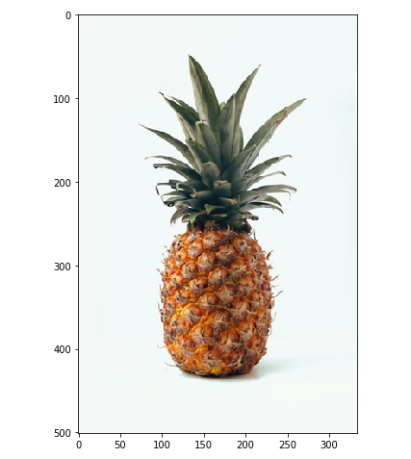 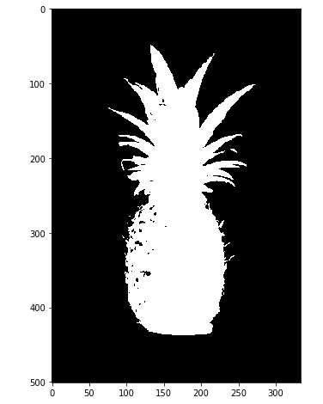

# Blurring for removing the noise   
img_blur = cv2.bilateralFilter(img, d = 7,   
 sigmaSpace = 75, sigmaColor =75)# Convert to grayscale   
img_gray = cv2.cvtColor(img_blur, cv2.COLOR_RGB2GRAY)# Apply the thresholding  
a = img_gray.max()   
_, thresh = cv2.threshold(img_gray, a/2+60, a,cv2.THRESH_BINARY_INV)  
plt.imshow(thresh, cmap = 'gray')

1. Colour Picker: A colour picker is a feature of virtually all software or online image and text editing tools. It allows you to choose the colours of visual elements like text or shapes in a document or graphic.
2. Colour detection: Colour detection is a technique of detecting any colour in a given range of HSV (hue saturation value) colour space.

1. Background Subtraction: Background subtraction is a major preprocessing step. In many vision-based applications. For example, consider the case of a visitor counter where a static camera takes the number of visitors entering or leaving the room, or a traffic camera extracting information about the vehicles etc. In all these cases, first you need to extract the person or vehicles alone. Technically, you need to extract the moving foreground from static background.
2. Skin Detection Method: Process of finding skin-colored pixels and regions in an image or a video . Often used as a cue for detecting, localizing and observing targets containing skin(like faces and hands in an image) . Plays an important role in human motion analysis and face detection
3. **Algorithm**

* Background Subtraction :-

[cv::BackgroundSubtractor](https://docs.opencv.org/4.x/d7/df6/classcv_1_1BackgroundSubtractor.html) object will be used to generate the foreground mask. In this example, default parameters are used, but it is also possible to declare specific parameters in the create function.

//create Background Subtractor objects

Ptr<BackgroundSubtractor> pBackSub;

if (parser.get<[String](https://docs.opencv.org/4.x/dc/d84/group__core__basic.html)>("algo") == "MOG2")

pBackSub = [createBackgroundSubtractorMOG2](https://docs.opencv.org/4.x/de/de1/group__video__motion.html)();

else

pBackSub = [createBackgroundSubtractorKNN](https://docs.opencv.org/4.x/de/de1/group__video__motion.html)();

A [**cv::VideoCapture**](https://docs.opencv.org/4.x/d8/dfe/classcv_1_1VideoCapture.html) object is used to read the input video or input images sequence.

VideoCapture capture( [samples::findFile](https://docs.opencv.org/4.x/d6/dba/group__core__utils__samples.html)( parser.get<[String](https://docs.opencv.org/4.x/dc/d84/group__core__basic.html)>("input") ) );

if (!capture.isOpened()){

//error in opening the video input

cerr << "Unable to open: " << parser.get<[String](https://docs.opencv.org/4.x/dc/d84/group__core__basic.html)>("input") << endl;

return 0;

}

Every frame is used both for calculating the foreground mask and for updating the background. If you want to change the learning rate used for updating the background model, it is possible to set a specific learning rate by passing a parameter to the apply method.

//update the background model

pBackSub->apply(frame, fgMask);

The current frame number can be extracted from the cv::VideoCapture object and stamped in the top left corner of the current frame. A white rectangle is used to highlight the black colored frame number.

//get the frame number and write it on the current frame

rectangle(frame, cv::Point(10, 2), cv::Point(100,20),

cv::Scalar(255,255,255), -1);

stringstream ss;

ss << capture.get(CAP_PROP_POS_FRAMES);

string frameNumberString = ss.str();

putText(frame, frameNumberString.c_str(), cv::Point(15, 15),

FONT_HERSHEY_SIMPLEX, 0.5 , cv::Scalar(0,0,0));

We are ready to show the current input frame and the results.

//show the current frame and the fg masks

imshow("Frame", frame);

imshow("FG Mask", fgMask);

**Git link:**

<https://github.com/kritiniranjan/Virtual-Painter-using-OPENCV/tree/main>

**Git and Reference Links**

<https://learnopencv.com/contour-detection-using-opencv-python-c/>

<https://ijsrst.com/paper/7305.pdf>

<https://www.ijtra.com/view/virtual-paint-application-by-hand-gesture-recognition-system.pdf>

<https://analyticsindiamag.com/how-to-create-a-virtual-painting-app-using-opencv/>

<https://learnopencv.com/edge-detection-using-opencv/>

<https://www.geeksforgeeks.org/erosion-dilation-images-using-opencv-python/>

<https://blog.electroica.com/eye-dropper-color-picker-tool-in-python-using-opencv/>

<https://docs.opencv.org/4.5.3/dd/d49/tutorial_py_contour_features.html>

<https://depts.washington.edu/acelab/proj/dollar/index.html>

<https://dl.acm.org/doi/abs/10.1145/1753326.1753654>

<https://www.google.com/search?q=what+is+color+detection+in+opencv&hl=en_GB&pli=1&authuser=1>

https://www.life2coding.com/how-to-create-a-rgb-color-picker-for-images-using-opencv-python/